 

# DESIGN AND FABRICATION OF AUTOMATIC SEED

# SOWING MACHINE

**A PROJECT REPORT**

***Submitted by***

**G KABINESH (927622BME031)**

**K KANISHKAR (927622BME032)**

**V KANNYA DHARSHINI (927622BME033)**

***in partial fulfillment for the award of the degree***

***of***

BACHELOR OF ENGINEERING

**IN**

# MECHANICAL ENGINEERING

**M.KUMARASAMY COLLEGE OF ENGINEERING, KARUR**

ANNA UNIVERSITY: CHENNAI 600 025

# NOV 2023

 

# DESIGN AND FABRICATION OF AUTOMATIC SEED

# SOWING MACHINE

**A PROJECT REPORT**

***Submitted by***

**G KABINESH (927622BME031)**

**K KANISHKAR (927622BME032)**

**V KANNYA DHARSHINI (927622BME033)**

***in partial fulfillment for the award of the degree of***

**BACHELOR OF ENGINEERING**

***in***

MECHANICAL ENGINEERING

# M.KUMARASAMY COLLEGE OF ENGINEERING, KARUR

ANNA UNIVERSITY: CHENNAI 600 025

# NOV 2023

## M.KUMARASAMY COLLEGE OF ENGINEERING, KARUR

BONAFIDE CERTIFICATE

Certified that this project report **“DESIGN AND FABRICATION OF AUTOMATIC SEED SOWING MACHINE”** is the bonafide work of **“G KABINESH (927622BME031)**

**K KANISHKAR (927622BME032), V KANNYA DHARSHINI (927622BME033)** who carried out the project work during the academic year 2021 – 2022 under my supervision. Certified further, that to the best of my knowledge the work reported herein does not form part of any other project report or dissertation on the basis of which a degree or award was conferred on an earlier occasion on this or any other candidate.

|  |  |  |  |
| --- | --- | --- | --- |
| **SIGNATURE** | | **SIGNATURE** | |
| Dr. M. MOHAN PRASAD M.E., MBA., Ph.D. | | Dr. M. MOHAN PRASAD M.E., MBA., Ph.D. | |
| **HEAD OF THE DEPARTMENT** | | **SUPERVISOR** | |
| Department of Mechanical Engineering, | Department of Mechanical | |
| M.Kumarasamy College of Engineering, | | M.Kumarasamy College of Engineering, | |
| Thalavapalayam, Karur-639113. | | Thalavapalayam, Karur-639113. | |

## This project report has been submitted for the end semester project viva voce Examination held on

INTERNAL EXAMINER EXTERNAL EXAMINER

## DECLARATION

We affirm that the Project titled **“DESIGN AND FABRICATION OF AUTOMATIC SEED SOWING MACHINE”** being submitted in partial fulfillment of for the award of Bachelor of Engineering in Mechanical Engineering, is the original work carried out by us. It has not formed the part of any other project or dissertation on the basis of which a degree or award was conferred on an earlier occasion on this or any other candidate.

## Student name Signature

1. G KABINESH ---------------------------

## 2. K KANISKAR ----------------------------

3. V KANNYA DHARSHINI ---------------------------

Name and signature of the supervisor with date

# ACKNOWLEDGEMENT

Our sincere thanks to Thiru. M. Kumarasamy, Chairman and Dr. K. Ramakrishnan, B.E, Secretary of M. Kumarasamy College of Engineering for providing extra ordinary infrastructure, which helped us to complete the project in time.

It is a great privilege for us to express our gratitude to our esteemed Principal Dr.B.S. Murugan M.E., Ph.D. for providing us right ambiance for carrying out the project work.

We would like to thank Dr.M. Mohan Prasad M.E, MBA., Ph.D, Head, Department of Mechanical Engineering, for their unwavering moral support throughout the evolution of the project.

We offer our whole hearted thanks to our internal guide Dr. M Mohan Prasad M.E., Ph.D., Professor, Department of Mechanical Engineering, for her/his constant encouragement, kind co-operation, valuable suggestions and support rendered in making our project a success.

We offer our whole hearted thanks to our project coordinator Dr .H Vinoth Kumar M.E., Ph.D.,Assistant Professor,Department of Mechanical Engineering, for her/his constant encouragement, kind co-operation, valuable suggestions and support rendered in making our project a success.

We glad to thank all the Teaching and Non-Teaching Faculty Members of Department of Mechanical Engineering for extending a warm helping hand and valuable suggestions throughout the project.

Words are boundless to thank Our Parents and Friends for their constant encouragement to complete this project successfully.

# INSTITUTION VISION & MISSION

**Vision**

* To emerge as a leader among the top institutions in the field of technical education.

# Mission

* Produce smart technocrats with empirical knowledge who can surmount the global challenges.
* Create a diverse, fully-engaged, learner-centric campus environment to provide quality education to the students.
* Maintain mutually beneficial partnerships with our alumni, industry and professional associations.

# DEPARTMENT VISION, MISSION, PEO, PO & PSO

**Vision**

* To create globally recognized competent Mechanical engineers to work in multicultural environment.

# Mission

* To impart quality education in the field of mechanical engineering and to enhance their skills, to pursue careers or enter into higher education in their area of interest.
* To establish a learner-centric atmosphere along with state-of-the-art research facility.
* To make collaboration with industries, distinguished research institution and to become a centre of excellence

# PROGRAM EDUCATIONAL OBJECTIVES (PEOS)

The graduates of Mechanical Engineering will be able to

* PEO1: Graduates of the program will accommodate insightful information of engineering principles necessary for the applications of engineering.
* PEO2: Graduates of the program will acquire knowledge of recent trends in technology and solve problem in industry.
* PEO3: Graduates of the program will have practical experience and interpersonal skills to work both in local and international environments.
* PEO4: Graduates of the program will possess creative professionalism, understand their ethical responsibility and committed towards society.

# PROGRAM OUTCOMES

**The following are the Program Outcomes of Engineering Graduates:Engineering Graduates will be able to:**

1. **Engineering knowledge:** Apply the knowledge of mathematics, science, engineering fundamentals, andan engineering specialization to the solution of complex engineering problems.
2. **Problem analysis:** Identify, formulate, review research literature, and analyze complex engineering problems reaching substantiated conclusions using first principles of mathematics, natural sciences, and engineering sciences.
3. **Design/development of solutions:** Design solutions for complex engineering problems and design system components or processes that meet the specified needs with appropriate consideration for the public health and safety, and the cultural, societal, and environmental considerations.
4. **Conduct investigations of complex problems:** Use research-based knowledge and research methods including design of experiments, analysis and interpretation of data, and synthesis of the information to provide valid conclusions.
5. **Modern tool usage:** Create, select, and apply appropriate techniques, resources, and modern engineering and IT tools including prediction and modeling to complex engineering activities with an understanding of the limitations.
6. **The engineer and society:** Apply reasoning informed by the contextual knowledge to assess societal, health, safety, legal and cultural issues and the consequent responsibilities relevant to the professional engineering practice.
7. **Environment and sustainability:** Understand the impact of the professional engineering solutions in societal and environmental contexts, and demonstrate the knowledge of, and need for sustainable development.
8. **Ethics:** Apply ethical principles and commit to professional ethics and responsibilities and norms of the engineering practice.
9. **Individual and team work:** Function effectively as an individual, and as a member or leader in diverse teams, and in multidisciplinary settings.
10. **Communication:** Communicate effectively on complex engineering activities with the engineering community and with society at large, such as, being able to comprehend and write effective reports and design documentation, make effective presentations, and give and receive clear instructions.
11. **Project management and finance:** Demonstrate knowledge and understanding of the engineering and management principles and apply these to one’s own work, as a member and leader in a team, to manage projects and in multidisciplinary environments.
12. **Life-long learning:** Recognize the need for, and have the preparation and ability to engage in independent and life-long learning in the broadest context of

technological change.

**PROGRAM SPECIFIC OUTCOMES (PSOs)**

**The following are the Program Specific Outcomes of Engineering Graduates:** The students will demonstrate the abilities

* 1. **Real world application:** To comprehend, analyze, design and develop innovative products and provide solutions for the real-life problems.
  2. **Multi-disciplinary areas:** To work collaboratively on multi-disciplinary areas and make quality projects.

**Research oriented innovative ideas and methods:** To adopt modern tools, mathematical, scientific and engineering fundamentals required to solve industrial and societal problems

|  |  |  |
| --- | --- | --- |
| **Course Outcomes** | At the end of this course, learners will be able to: | **Knowledge Level** |
| CO-1 | Identify the issues and challenges related to industry, society and environment. | Apply |
| CO-2 | Describe the identified problem and formulate the possible solutions | Apply |
| CO-3 | Design / Fabricate new experimental set up/devices to provide solutions for  the identified problems | Analyse |
| CO-4 | Prepare a detailed report describing the project outcome | Apply |
| CO-5 | Communicate outcome of the project and defend by making an effective oral presentation. | Apply |

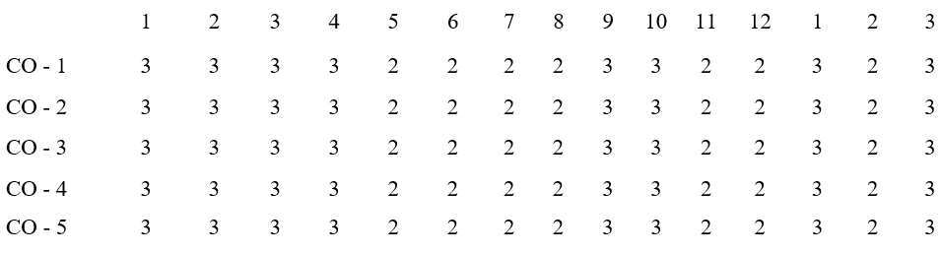

**MAPPING OF PO & PSO WITH THE PROJECT OUTCOME**

**Program**

**Course**

**Outcomes**

**ProgramOutcomes**

**Specific**

**Outcomes**

|  |  |  |
| --- | --- | --- |
| **S.NO.** | **TITLE** | **PAGE NO.** |
| **1** | **Abstract** | **9** |
| **2** | **Introduction** | **10** |
| **3** | **Construction**  **3.1 Working principle**  **3.2. components used**  **3.3. working of components** | **12** |
| **4** | **4.1 Advantages**  **4.2 Applications** | **19** |
| **5** | **Reference**  **5.1 Review 1**  **5.2 Review 2** | **20** |
| **6** | **Block diagram** | **22** |
| **7** | **Cost estimation** | **23** |
| **8** | **Materials used** | **24** |
| **9** | **Conclusion** | **25** |

**ABSTRACT**

Agriculture is the major sector in the world that plays a vital role in developing the economy of a nation. Agro technology is the process of implementing the recent technologies to develop the crops that are being produced. The use of agro technology not only helps in improving the efficiency of the crop that are being produced but also helps in developing devices that are suitable for doing mechanical works in the fields. This result in minimization of the total cost of production, saving of time and reduction in the effort involved in the process. The new technology should also be economically feasible and hence the behavior of the technology and its role in the society is an important consideration before developing a new product or process. In this work a seed sowing machine has been developed that help the farmers in harvesting the best crop with least efforts. A mechanical device that helps in sowing operation which is operated using DC drive has been developed.

**INTRODUCTION**

In current world, every process is getting automated and people are getting used to adopt smart techniques to get their work done. It can be seen that with flow of time, how seed sowing techniques and equipment’s have kept on progressing. Proper seed sowing is very important part of agricultural process and for the same purpose hand operated seed sowing machine have been designed and developed. Despite agriculture being one of the most important fields for determining the growth of a country, it is lagging in terms of smart working. One of the biggest irony is agriculture being the main occupation in many countries still it lags in using the smart techniques in this field. If technology is introduced in farming techniques there are chances that ever growing populating in the coming future might be fed adequately. To suffice such a large amount, agricultural yield must also be increased rapidly. Due to poor seed quality & inefficient farming practices, and lack of cold storage and harvest spoilage, nearly 30% of the farmer’s produce is wasted. Not in just theory practically we can see how automation helps in increasing output of farming, in US, where automation techniques in agricultural farming has already been implemented the cereal yield is nearly 6600 Kg/Hectare which is three times more than in India whose cereal yield is just 2600 Kg/Hectare approximately. These figures clearly shows that there is great need of introducing automation techniques in every small and big agricultural farming because, if appropriate measures are not taken at the right time, even though currently many countries has adequate stock of food to suffice its population, a time may come when same will not be able to feed its entire population. As a result of it the

development of such countries will severely be affected and they may not be able

to become a developed nation. Automation in seed sowing will help in proper use of available resources. To implement automation in the process of sowing seeds in agricultural farming, the machines that are already being used can be improved in design or new machines or attachments can be developed to do the necessary operations. But these machines or attachments should be cost effective and be affordable to the farmers. Hence a less expensive, distinct machine or attachment has to be designed and developed so that it can be used for different crops and in different seasons. It will help to increase output with same amount of input by sowing the seed at proper distance so that each seed gives best output as it is known that sowing of seed with proper gap is an important parameter in farming. For an agriculture sector to be successful one needs to add the booming technologies as input and take care of the processes and at the same time knowing the behavior of the technology and the major role that it is going to play in the sector of one’s interest. In the present growing aspect the need to utilize the available technologies has become necessity in order to gain the best result

**CONSTRUCTION**

The base frame which acts a chassis of vehicle is fabricated with the help of square tubes and channels by metal cutting and metal joining process called welding. Four wheels are attached to the frame for its displacement, in which two at rear axle shaft and other two at front axle shaft. These two axle shafts are mounted to base frame with the help of bearing supported ends. The front axle shaft has a number of seed sower setup in it, which consists of hollow chamber with lid to load the seeds into it and chamber consists of holes on its surface for sowing the seeds. Crank wheels are connected to both the shafts and are coupled together with the help of chain drive. A sharp edged rod is joint at the front of the sower which made some path for sowing the seed in the ground and followed by the seed sowing process a plate is attached at the back of the machine which closes the path which is created by the sharp edge. A DC drive is directly connected to the rear axle shaft and get fixed to the base frame, source to operate the drive is provided with the help of battery which is placed on the base frame.

**WORKING PRINCIPLE**

Initially seeds are loaded inside all the chambers and sealed with the help of lids provided. Once the seeds are loaded setup is placed on the field where sowing operation to be performed. The circuit between the drive and power source (battery) is closed which allows current to pass through the motor and makes it to rotate about its axis. This rotation makes the rear axle shaft coupled with it to rotate, thus makes an entire setup to move on the field, similarly crank wheel attached to the shaft also gets rotated and transfers the obtained rotation to the another crank wheel mounted at the front axle. The rotation of front axle shaft tends to rotate seed loaded chamber and causes the seeds to discharge from the holes of chamber.

# 

# COMPONENTS USED

1. Frame
2. Shaft
3. Bearing
4. Metal strip
5. Chain drive
6. D c motor
7. Battery
8. Seed sower
9. Wheel

**WORKING OF COMPONENT**

**CHAIN DRIVE:**

Chain drive is a way of transmitting mechanical power from one place to another. It is often used to convey power to the wheels of a vehicle, particularly bicycles and motorcycles.

The power is conveyed by a roller chain, known as the drive chain, passing over a sprocket gear, with the teeth of the gear meshing with the holes in the links of the chain. The gear is turned, and this pulls the chain putting mechanical force

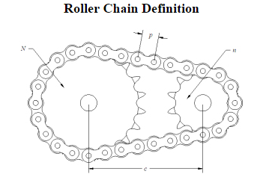

**DC MOTOR:**

The electrical motor is an instrument, which converts electrical energy into mechanical energy. According to faraday’s law of Electromagnetic induction, when a current carrying conductor is placed in a magnetic field, it experiences a mechanical force whose direction is given by Fleming’s left hand rule.

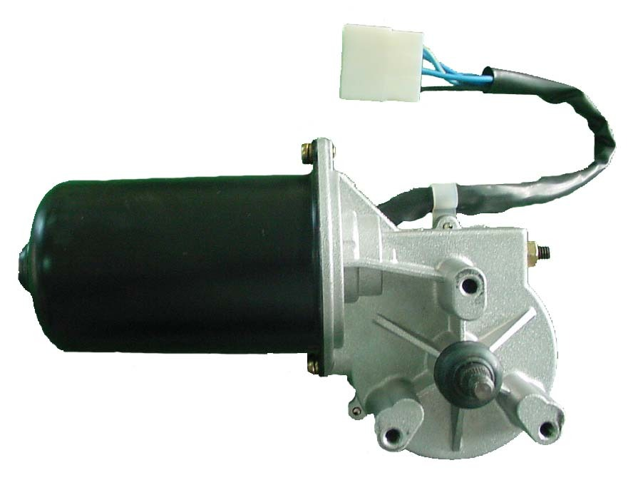

**DC BATTERY:**

Battery Specification:

Capacity: 12V and 7.3 Ah

Rechargeable battery one

Battery type: Lead – acid battery

Charge capacity: 4.2 hour loading condition

Charging time: 3 hour

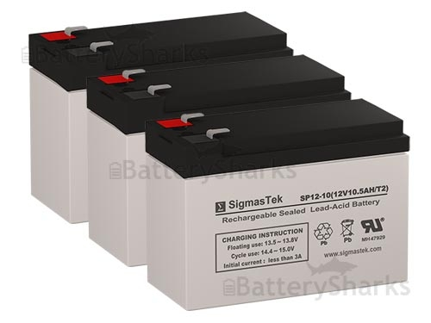

**SEED SOWER WHEEL:**

The mechanism of a seed drill or fertilizer distributor which delivers seeds or fertilizers from the hopper at selected rates is called seed metering mechanism.

Cup feed mechanism- It is a mechanism consisting of cups or spoons on the periphery of a vertical rotating disc which picks up the seeds from the hopper and delivers them into the seed tubes. It consists of a seed hopper which has two parts. The upper one is called grain box and the lower one is called feed box. The seed delivery mechanism consists of a spindle, carrying a number of discs with a ring of cups attached to the periphery of each disc. The spindle with its frame and attachment is called seed barrel.

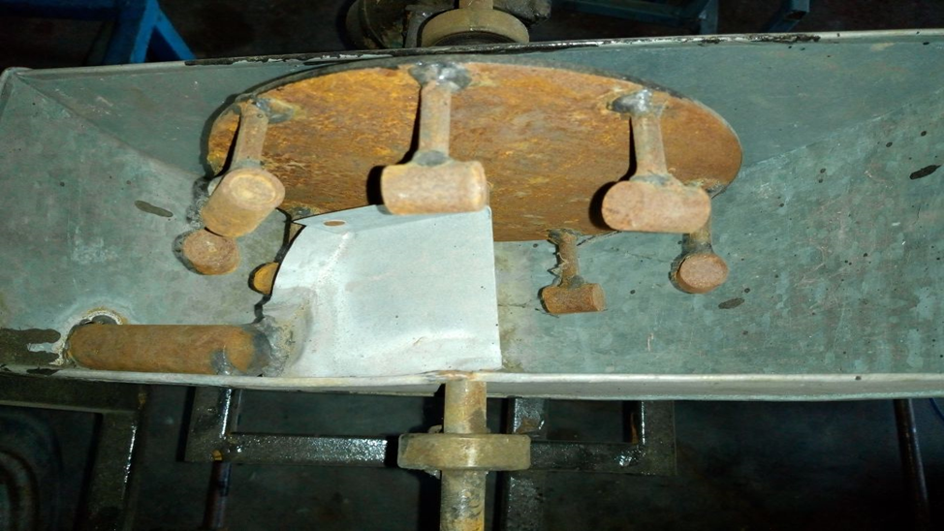

**ADVANTAGES**

* Construction is simple; components used are easily available in markets.
* Less costly when compared with existing automation systems.
* Less human effort is required, labor charges are also reduced with the help of this setup.
* Time consumption for seed sowing operation is completely reduced.
* Less maintenance is enough for its better performance.

**APPLICATIONS**

It is mainly designed for small scale fields, by increasing the seed loading chamber size and capacity of drive used this setup can also be used for medium and large scale fields.

**LITERATURE REVIEW 1**

Bhushan Deshmukh Durgesh Verma

* FABRICATION AND IMPLEMENTATION OF AUTOMATIC SEED SOWING MACHINE
* In the farming process, often used conventional seeding operation takes more time and more labor. The seed feed rate is more but the time required for the total operation is more and the total cost is increased due to labor, hiring of equipment. The conventional seed sowing machine is less efficient, time consuming. Today’s era is marching towards the rapid growth of all sectors including the agricultural sector. To meet the future food demands, the farmers have to implement the new techniques which will not affect the soil texture but will increase the overall crop production. In the farming process, often used conventional seeding operation takes more time and more labor. The seed feed rate is more but the time required for the total operation is also more and the total cost is increased due to labor, hiring of equipment. This machine reduces the efforts and total cost of sowing the seeds and fertilizer placement.

**LITERATURE REVIEW 2**

* Mr. Akshay Divate Miss. Drakshayini Muchandi Miss. Snehal Patil Prof. S. V. Phakade
* Mechatronical Seed Sowing Machine
* This paper is focused on seed sowing process using a Bluetooth operated machine. The integral construction of the machine is made simple to use. In the farming process, Conventional seeding operation takes more time and more labor. Due to more sowing rate the time required for the total operation is more and the labor cost is increased. So Automation in farming would provide one of the feasible solutions. For that, we are going to automate the seed sowing machine. This machine is controlled by a Smartphone. This project focuses on developing the Bluetooth operated mobile machine to minimize the working cost and increase the accuracy of seed sowing. A 12V battery is used which gives supply to the overall system of the machine, we can also connects solar panel to this circuit. PIC Microcontroller is used which controls the machine for desired sowing operation and a Bluetooth interface is used to navigate the machine

**BLOCK DIAGRAM**

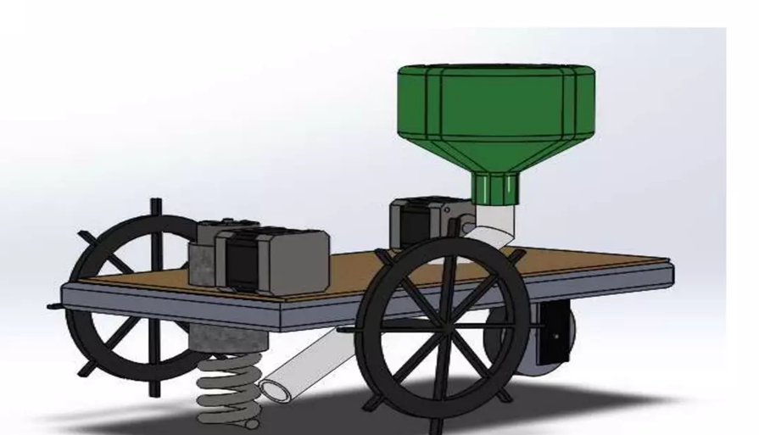

**COST ESTIMATON**

|  |  |  |
| --- | --- | --- |
| **SL.NO** | **DISCRIPTION** | **COST Rs:** |
| **1** | **BATTERY** | **1000** |
| **2** | **D C MOTOR** | **1100** |
| **3** | **BEARING** | **250** |
| **4** | **FRAME** | **300** |
| **5** | **SHAFT** | **200** |
| **6** | **METAL STRIP** | **400** |
| **7** | **CHAIN DRIVE** | **300** |
| **8** | **SEED SOWER** | **1500** |
| **9** | **TOTAL** | **5050** |

**MATERIAL USED**

|  |  |  |  |
| --- | --- | --- | --- |
| S.No | DESCIRPTION | QTY | MATERIAL |
| 1 | BATTERY | 1 | ELECTRICAL |
| 2 | D C MOTOR | 1 | ELECTRICAL |
| 3 | BEARING | 3 | STAINLESS STEEL |
| 4 | FRAME | AS PER REWUIRMENT | MILD STEEL |
| 5 | SHAFT | AS PER REWUIRMENT | MILD STEEL |
| 6 | METAL STRIP | AS PER REWUIRMENT | MILD STEEL |
| 7 | CHAIN DRIVE | 1 | STAINLESS STEEL |
| 8 | SEED SOWER | 4 | MILD STEEL |
| 9 | WHEEL | 3 | RUBBER |

**CONCLUSION**

The main focus of this system is its Automatic way of sowing the seeds. The seeds are been sowed in a proper sequence which results in proper germination of seeds. This automatic way of sowing seeds using a robot reduces the labor requirement. Here the wastage of seeds is also been reduced to a greater extent. This system has been developed for the sowing of seeds in an automatic way. Here with the help of a robot the seeds are been dispensed in the soil in a proper sequence hereby reducing the wastage of seeds The planting process of the onion crop only has been implemented by using this Seed Sowing V robot autonomously. This robot will help the farmers to do the farming process efficiently. The project can be enhanced to any other kinds of crop such as fruits, paddy, sugarcane etc. The robot can be designed with chain roller instead of normal wheel. Hence, it can be applicable to the real time agricultural field.